САПАРОВА Перизат Мухтаровна,
№131 жалпы орта білім беретін мектебінің ағылшын тілі пәні мұғалімі.
Шымкент қаласы

A PARALYMPIC CHAMPION
Learning objectives(s) that this lesson is contributing to (link to the Subject programme) |  | 5.4.4.1 read with some support a limited range of short fiction and non-fiction texts;  5.3.4.1 respond with limited flexibility at sentence level to unexpected comments on an increasing of general and curricular topics.
Lesson objectives |  | - Learner will be able to:  - - Identify the main idea from the text with support;  - - Express their ideas according to the topic “How I became a champion”.
Plan
Planned timings | Teacher's actions |  | Pupils` actions | Assessment | Resources
2 minutes  4 minutes | Greeting:  Teacher greets learners and responds teacher’s report on processing procedural questions. Therefore, teacher sets learning and lesson objectives.  Grouping.  Teacher divide learners into subgroup by strategy “Counting”.  Warm-up:Activity. “What do you think?”  Teacher asks learners their thoughts on today’s topic. Also, the teacher shows the picture on the interactive board.  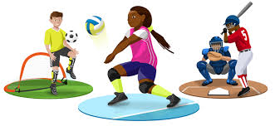  - What sports do you do?  - Which ones are team sport?  - Which ones need a board?  Useful expression:  I think …  In my opinion …  This picture shows …  Differentiation by resource  Teacher supports to show a useful expressions for compliting a task successfully. |  | Students respond to greeting and take their places  Students are divided into two groups by counting the numerals 1-13. As a result, even numbers will be the first group. The odd numbers are the second group  Students express their opinion through answer the question and guess the topic of the lesson. | Descriptor A learner  - makes up sentences through useful expression  - makes a description according to the pictures with support  - works in pairs  AFL: Teachers assessment in oral form. | Blackboard, whiteboard  PPT  Interactive board
4 minutes  10 minutes  5 minutes  5 minutes  10 minutes | Pre-reading task. Activity  “Match pictures with the box”  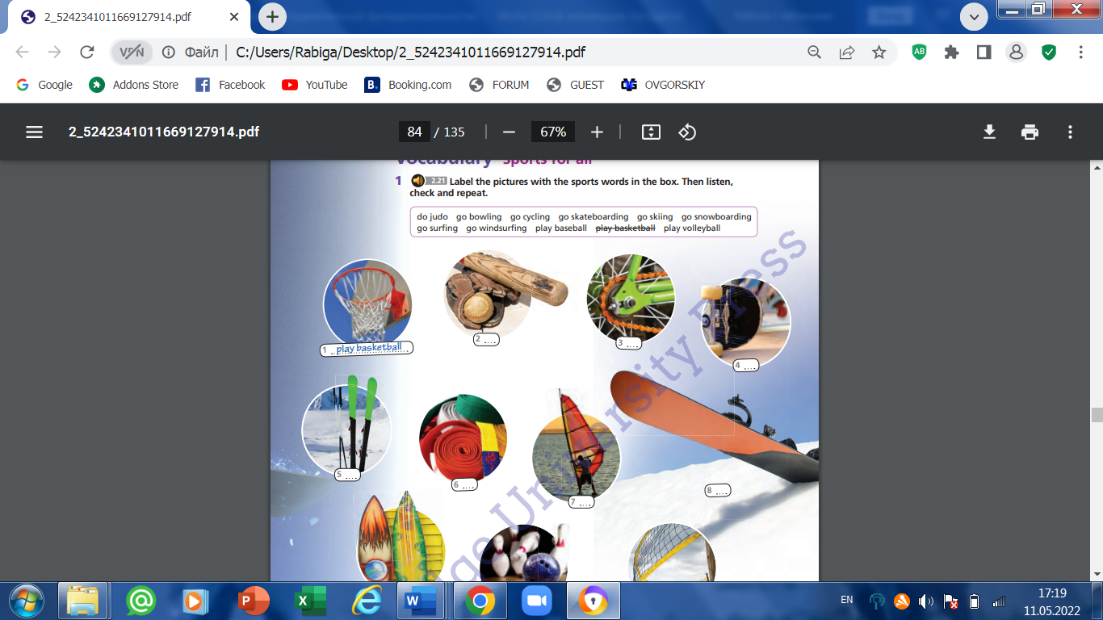While-reading task. “Connecting the Chain” Activity  Each group is given a text. Secretary of the group is chosen, who doesn’t read the text, but writes according to the words of his classmates. For example, if there are six students in a group, the text is divided into five parts, because each students reads the part of the text that belongs to him, tells the group secretary the main idea of the text, tries to convey it in own words and secretary writes it all down.  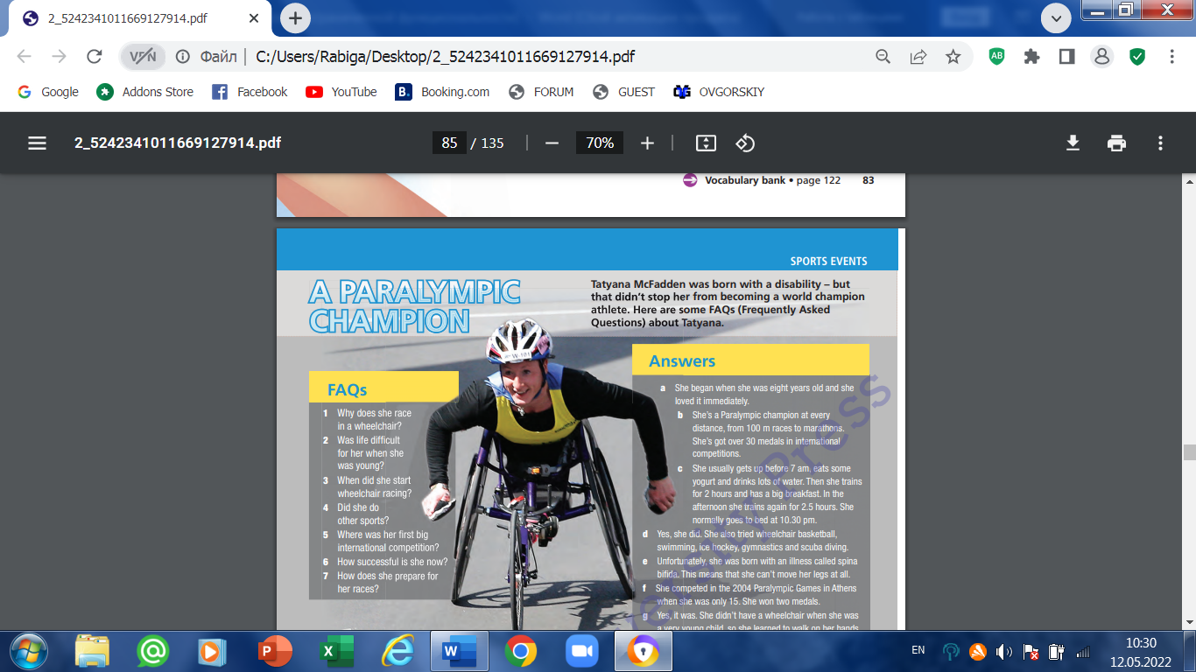McFadden was born in Leningrad, then Soviet Union, on 21 April 1989. She was born with spina bifida, a congenital disorder that paralyzed her from the waist down. After her birth mother abandoned her in an orphanage that was too poor to afford a wheelchair for her, she walked on her hands for the first six years of her life. While in the orphanage, she met Deborah McFadden, who was visiting Russia as a commissioner of disabilities for the U.S. Health Department.  McFadden began racing at the age of eight. Competing in the 2004 Summer Paralympics in Athens, Greece, she won a silver medal in the women's 100 metres – T54 event; a bronze medal in the women's 200 metres – T54 event.  Until 2009, McFadden specialized in shorter distance sprints. She entered the Chicago Marathon in 2009 as a lark. Unexpectedly, she won, finishing so soon that her mother didn't have her camera ready to record the victory.  McFadden's coach at the University of Illinois is Adam Bleakney, himself a veteran wheelchair racer.  Differentiation by roles within group  Each group leaders help to less able learners on processing reading task.  Post -reading task. Pair work  A teacher asks students to work individually and express their opinions on the given question  What helped Tatyana to become a champion?  Pre speaking task  Watch the teenagers in the video telling about their favorite . Then answer the question below  Task 4 What’s your favorite sport and why?  Speaking task  Method “Press Conference” (PW)  A teacher encourages students to take on the role of a sportsman\sportswoman and make a speech at the conference.  Deskmate should ask 1-2 questions to a sportsmen/ sportswoman  Task 5. Imagine yourselves as a sportsman\sportswoman at the conference on the topic ‘How I became a champion’ .  You have I minute to prepare your speech.  The following questions will help to organize your speech:  - What is your name?  - In what kind of sport did you participate?  - How did you train to win?  - What was your goal and did you achieve it?  - How did you feel yourself when you won?  - Your advice to your generation?  - Should they go in for sport and why? |  | Students should write new words on their vocabulary book.  Each group members take turns telling the main idea of part of the text to secretary. Teacher gives each student 1-1.5 minutes to read the text, depending on the size of the text. All students try to summarize the main idea of the text.  Learners answer the questions  Learners will watch the video and tell what their favorite sport is  Learners make a speech by answering the questions. | AFL: peer assessment  Descriptor:  A learner  -reads the text individually  -tells the secretary the main idea of the part of the text  AFL: Group assessment with criteria  Criteria  -provide main idea of the part of the text  - cover the core idea of the whole text  Descriptor: A learner  - works in pairs individually  - answers the question  Criteria :  -gives full answers  -uses related vocabulary to the topic.  - make a clear speech.  -connects the sentences coherently  -Answer deskmate’s questions  Peer assessment by criteria | Eyes Open  5th grade  Student’s book  Eyes Open  5th grade  Student’s book  Eyes open 1 student’s book  Disk 2  Real talk 8.3
5 minutes | Feedback. “Sailing ship”.  At the end of the lesson, teacher gives a card to each learners.  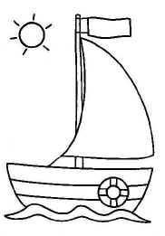  If you like the lesson paint the sail green  If you have some difficulty in the lesson paint yellow  If the lesson is difficult and the teacher’s help needed paint red  Homework.  Exercise 3, at page 85 |  | Learners express their success by painting pictures on the ship and teacher provides them with oral feedback |  | Cards  Colorful pencils

